**Project Planning Phase** - **Project Planning Template Sprint Delivery plan**

| Date | 22 October 2022 |
| --- | --- |
| Team ID | PNT2022TMID50829 |
| Project Name | Real time river water quality monitoring and Control system |
| Marks | 4 Marks |

**Project Tracker, Velocity & Burndown Chart: (4 Marks)**

| **Sprint** | **Total**  **Story**  **Points** | **Duration** | **Sprint Start Date** | **Sprint End**  **Date (Planned)** | **Story Points**  **Completed**  **(as on**  **Planned End**  **Date)** | **Sprint Release Date (Actual)** |
| --- | --- | --- | --- | --- | --- | --- |
| Sprint-1 | 20 | 6 Days | 24 Oct 2022 | 29 Oct 2022 | 20 | 29 Oct 2022 |
| Sprint-2 | 20 | 6 Days | 31 Oct 2022 | 05 Nov 2022 | 20 | 05 Nov2022 |
| Sprint-3 | 20 | 6 Days | 07 Nov 2022 | 12 Nov 2022 | 20 | 12 Nov 2022 |
| Sprint-4 | 20 | 6 Days | 14 Nov 2022 | 19 Nov 2022 | 20 | 19 Nov 2022 |

**Velocity:**

Imagine we have a 10-day sprint duration, and the velocity of the team is

20 (points per sprint). Let’s calculate the team’s average velocity (AV) per iteration unit (story points per day) .

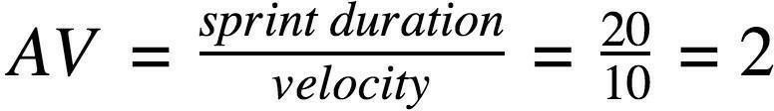

**Burndown Chart:**

A burn down chart is a graphical representation of work left to do versus time. It is often used in agile [software development m](https://www.visual-paradigm.com/scrum/what-is-agile-software-development/)ethodologies such as [Scrum. H](https://www.visual-paradigm.com/scrum/scrum-in-3-minutes/)owever, burn down charts can be applied to any project containing measurable progress over time.

<https://www.visual-paradigm.com/scrum/scrum-burndown-chart/><https://www.atlassian.com/agile/tutorials/burndown-charts>**Reference:** <https://www.atlassian.com/agile/project-management><https://www.atlassian.com/agile/tutorials/how-to-do-scrum-with-jira-software><https://www.atlassian.com/agile/tutorials/epics><https://www.atlassian.com/agile/tutorials/sprints><https://www.atlassian.com/agile/tutorials/burndown-charts><https://www.atlassian.com/agile/project-management/estimation>